**Digital Portfolio** 

STUDENT NAME: V.Nandhini   
REGISTER NO AND NMID: 222402536AND asunm16122402536 DEPARTMENT: Computer Science   
COLLEGE:Prince Shri Venkateswara Arts and Science College/Madras University

1



**PROJECT TITLE**

Digital Portfolio Using Front end WebDevelopment

2



**AGENDA**

1.Problem Statement   
2.Project Overview   
3.End Users   
4.Tools and Technologies   
5.Portfolio design and Layout   
6.Features and Functionality   
7.Results and Screenshots   
8.Conclusion   
9.Github Link

3/21/2024 **Annual Review**  3



**PROBLEM STATEMENT**

In today’s digital world, students and professionals need a simple and effective way to showcase their skills, achievements, and projects online. Traditional paper-based portfolios are difficult to update, share, and store. Many people struggle to find a user-friendly platform that allows them to present their work in a creative and organized way. Existing digital tools can be complex, expensive, or limited in features.

4



**PROJECT OVERVIEW**

The Digital Portfolio project aims to develop an online platform where users can create manage, and share their personal or professional work in an organized and visually appealing manner. This platform will allow students, artists, job seekers, and professionals to showcase their skills, projects, achievements, and experiences using various media formats such as text, images, videos, and documents

5



**WHO ARE THE END USERS?**

The end users of the Digital Portfolio are students, job seekers, freelancers, creative professionals, and anyone who needs to showcase their work, skills, or achievements online. For students, it serves as a platform to present academic projects, certificates, and extracurricular activities when applying for higher education or internships. Job seekers and professionals can use it to highlight their resumes, work experience, and completed projects to potential employers

6



**TOOLS AND TECHNIQUES**

The Digital Portfolio is built using modern web development tools and techniques to ensure a smooth and responsive user experience. Front-end technologies like HTML, CSS, and JavaScript are used to create a clean and interactive design. Frameworks such as Bootstrap help in making the layout responsive across different devices. On the back end, tools like PHP or Node.js along with databases like MySQL or Firebase store user data securely

7

**POTFOLIO DESIGN AND LAYOUT**

The design and layout of the Digital Portfolio are clean, user-friendly, and easy to navigate. It features a customizable homepage where users can add their name, profil picture, and a short introduction. Sections like “About Me,” “Skills,” “Projects,”“Education,” and “Experience” are organized clearly with the option to add text, image videos, and documents.

8



**FEATURES AND FUNCTIONALITY**

The Digital Portfolio includes a variety of features to help users easily create and manage their online profiles. Key features include customizable templates, drag-and-drop content editing, and sections for personal information, skills, projects, education and experience. Users can upload images, videos, PDFs, and links to showcase their work.

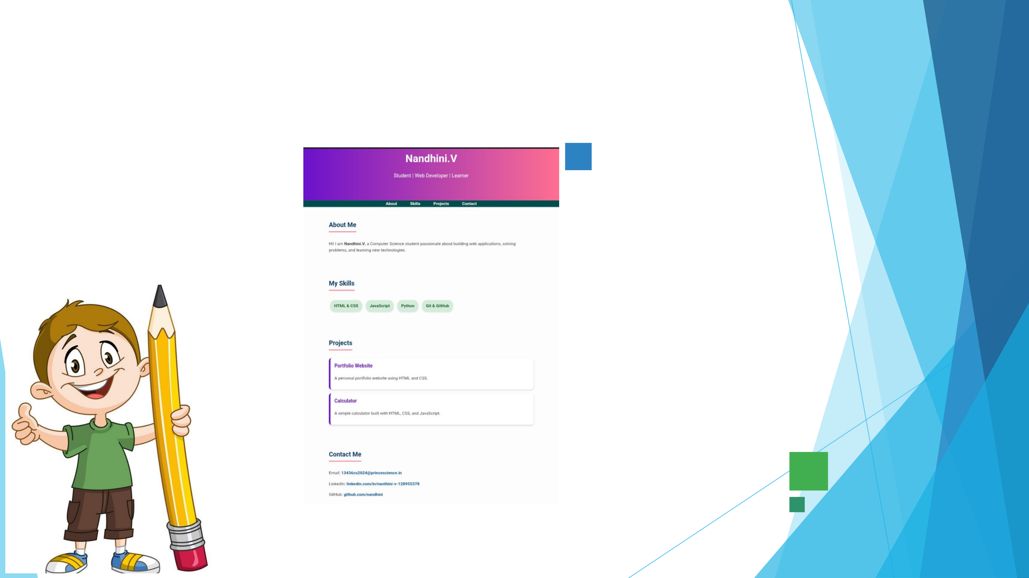

**RESULTS AND SCREENSHOTS**

3/21/2024 **Annual Review**  10



**CONCLUSION**

In conclusion, a Digital Portfolio is a valuable tool for students, professionals, and creatives to showcase their skills, work, and achievements in an organized and moder way. It replaces traditional paper-based portfolios with a more flexible, accessible, an visually appealing solution. With user-friendly features, customizable design, and support for various media types, it helps individuals create a strong online presence.

11